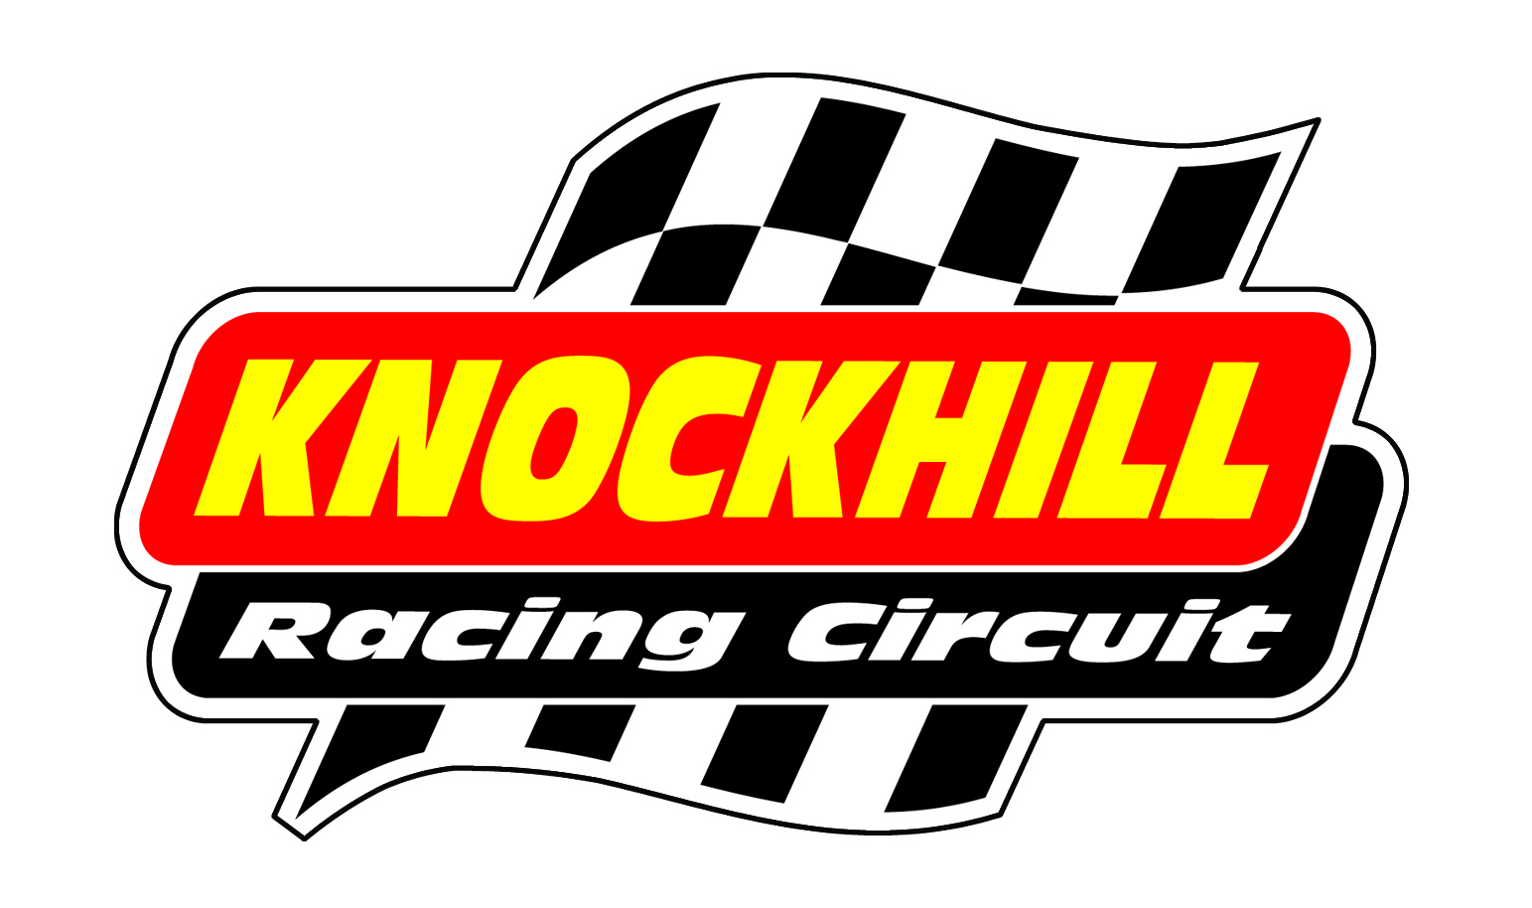
2012 Provisional Dates

January
Sunday 8th | Grant Construction Rally Stages
Sunday 29th | Hot Hatch Car Trackday
February
Sunday 26th | Hot Hatch Car Trackday
March
Sunday 25th | Hot Hatch Car Trackday
April
Sunday 8th | Scottish Championship Car Racing (SMRC)
Sunday 22nd | Hot Hatch Car Trackday
Wednesday 25th | Stock Car Summer Series (6.30pm)
Saturday 28th / Sunday 29th | Scottish Championship Bike Racing (Knockhill Motor Sports Club)
May
Saturday 5th / Sunday 6th | Scottish Championship Car Racing (SMRC)
Saturday 13th | British Championship Rally Cross
Sunday 20th | Hot Hatch Car Trackday
Wednesday 30th | Stock Car Summer Series (6.30pm)
June
Sunday 3rd | Scottish Championship Car Racing (Knockhill Motor Sports Club)
Sunday 10th | Modified Live
Saturday 16th / Sunday 17th | The Official Scottish Motorshow
Fri 22nd / Sat 23rd / Sunday 24th | MCE British Superbike Championship
Wednesday 27th | Stock Car Summer Series (6.30pm)
Saturday 30th | NEMCRC Motorcycle Racing
July
Sunday 1st | NEMCRC Motorcycle Racing
Sunday 8th | Knockhill Motor Sports Club Car Racing
Sunday 15th | Ford Live & Hot Hatch Car Trackday
Wednesday 18th | Stock Car Summer Series (6.30pm)
Saturday 21st / Sunday 22nd | Scottish Championship Car Racing + Mazda (SMRC)
Saturday 28th / Sunday 29th | Scottish Championship Bike Racing (Knockhill Motor Sports Club)
August
Saturday 4th / Sunday 5th | Motorrad Central Scotland Extreme Bike Weekend
Sunday 12th | Scottish Championship Car Racing (SMRC)
Sunday 19th | Total Jap Car Scotland & Hot Hatch Car Trackday
Saturday 25th / Sunday 26th | MSA British Touring Car Championship
Wednesday 29th | Stock Car Summer Series (6.30pm)
September
Sunday 2nd | Scottish Championship Bike Racing (Knockhill Motor Sports Club)
Sunday 9th | Classic Speedfair featuring GT Cup (Knockhill Motor Sports Club)
Sunday 16th | Performance French Cars & Hot Hatch Car Trackday
Sunday 23rd | Scottish Championship Car Racing (SMRC)
Saturday 29th / Sunday 30th | British Drifting Championship
October
Sunday 7th | Scottish Championship Car Racing (SMRC)
Sunday 21st | Street Car Scotland & Hot Hatch Car Trackday
Sunday 28th | Knockhill Motor Sports Club Car Racing
November
Sunday 18th | Hot Hatch Car Trackday
December
Sunday 16th | Hot Hatch Car Trackday

