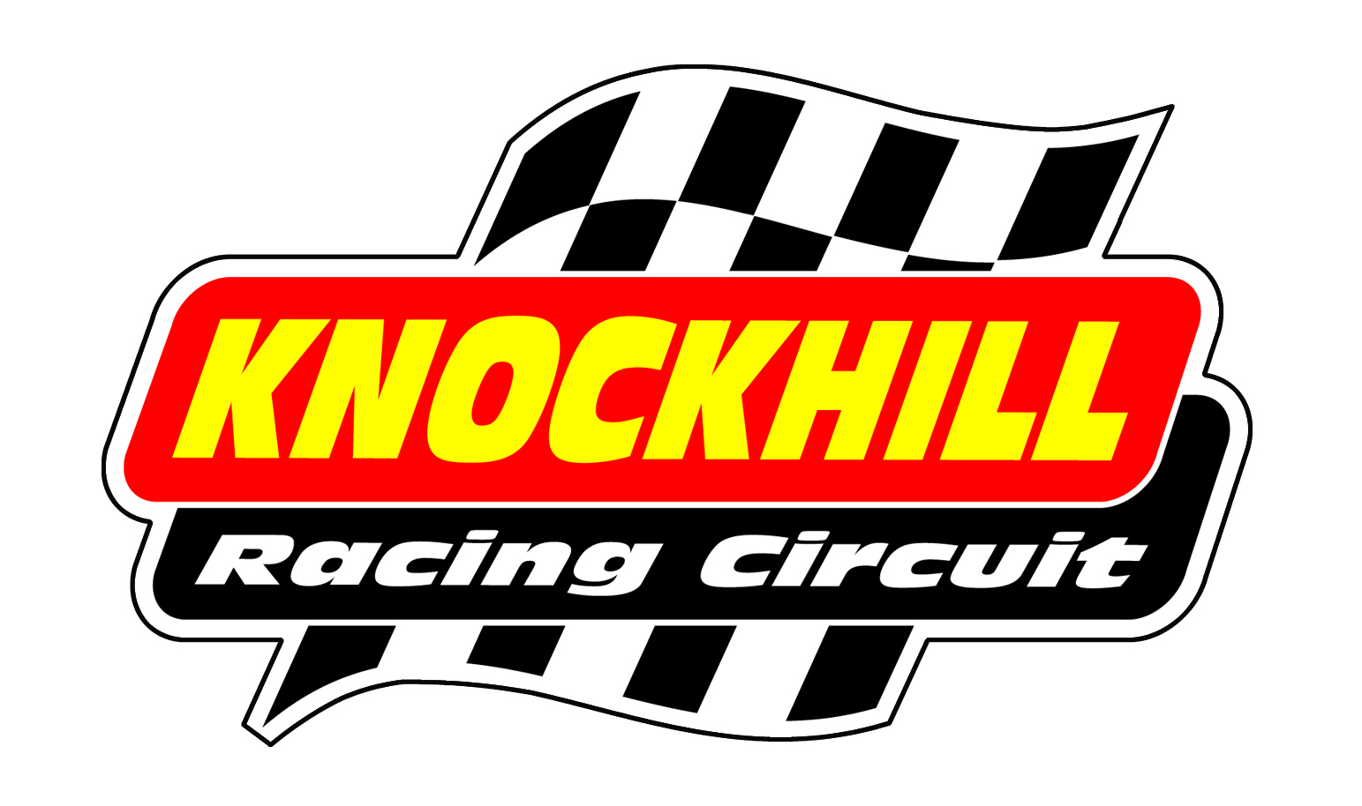2012 Provisional Bike Trackday Dates
Date | Trackday Type | Timings | Groups | Advance Price | On the Day Price
Sunday 18th March | Bike Trackday Session (Intermediate/Advance Riders only) | 10am – 5pm | This day will run along side our Bike Testing sessions. There is 1 Group for Bike Trackday Customers. | £75 | £85
Friday 30th March | Bike Trackday Club Members Night | 4.30pm – 6pm | For members only. We will run 2 groups | FREE  (members only) | Advance booking only
Sunday 1st April | Bike Trackday Full Day (Sessions) | 9am – 5pm  (Half days 9am – 12.30pm & 1.30pm – 5pm | Novice, Intermediate & Advance | Half Day £60  Full Day £90 | Half Day £70  Full Day £100
Friday 13th April | Bike Trackday Open Session | 10am – 5pm | Open Session, max 50 riders full day. | £165 | £190
Friday 13th April | Bike Track Night | 6pm – 8pm | Novice/Intermediate and Intermediate/Advanced | £55 | £65
Wednesday 18th April | Intro Bike Track Night | 6pm – 8pm | Open Session, max 30 riders for First Timers and Novice riders only. | £85 | £95
Saturday 21st April | Bike Track Morning | 9am – 1pm | Novice, Intermediate & Advanced | £65 | £75
Monday 7th May | Bike Trackday Open Session | 10am – 5pm | Open Session, max 50 riders full day. | £165 | £190
Monday 7th May | Bike Track Night | 6pm – 8pm | Novice/Intermediate and Intermediate/Advanced | £55 | £65
Thursday 17th May | Intro Bike Track Night | 6pm – 8pm | Open Session, max 30 riders for First Timers and Novice riders only. | £85 | £95
Friday 25th May | Bike Trackday Open Session | 10am – 5pm | Open Session, max 50 riders full day. | £165 | £190
Monday 28th May | Bike Track Night | 6pm – 8pm | Novice/Intermediate and Intermediate/Advanced | £55 | £65
Saturday 2nd June | Bike Track Morning | 9am – 1pm | Novice, Intermediate & Advanced | £65 | £75
Monday 11th June | Intro Bike Track Night | 6pm – 8pm | Open Session, max 30 riders for First Timers and Novice riders only. | £85 | £95
Monday 18th June | Bike Trackday Open Session | 10am – 5pm | Open Session, max 50 riders full day. | £165 | £190
Monday 18th June | Bike Track Night | 6pm – 8pm | Novice/Intermediate and Intermediate/Advanced | £55 | £65
Saturday 7th July | Bike Track Morning | 9am – 1pm | Novice, Intermediate & Advanced | £65 | £75
Friday 13th July | Bike Trackday Open Session | 10am – 5pm | Open Session, max 50 riders full day. | £165 | £190
Friday 13th July | Bike Track Night | 6pm – 8pm | Novice/Intermediate and Intermediate/Advanced | £55 | £65
Saturday 4th & Sunday 5th August | Bike Trackday Sat & Sun  (Motorrad Extreme Event) | 9am – 5pm | Novice, Intermediate & Advanced  *free onsite camping available | £99 (book by 25th June, £130 after) | £130
Saturday 4th & Sunday 5th August | Simon Pavey Extreme GS Off-Road Challenge  (Motorrad Extreme Event) | 9am – 5pm | Beginner, intermediate and expert levels along with a choice of BMW models. The event will be a GS trials skills challenge, purely for fun! Your ability and experience level doesn’t matter, it’s all about having a go. The challenge will take place on our bikes, so you don’t need to worry about any damage either. | £189  Includes Bike hire | £189  Includes Bike hire
Saturday 11th August | Bike Track Morning | 9am – 1pm | Novice, Intermediate & Advanced | £65 | £75
Monday 13th August | Bike Trackday Open Session | 10am – 5pm | Open Session, max 50 riders full day. | £165 | £190
Monday 13th August | Bike Track Night | 6pm – 8pm | Novice/Intermediate and Intermediate/Advanced | £55 | £65
Thursday 16th August | Intro Bike Track Night | 6pm – 8pm | Open Session, max 30 riders for First Timers and Novice riders only. | £85 | £95
Saturday 1st September | Bike Track Morning | 9am – 1pm | Novice, Intermediate & Advanced | £65 | £75
Monday 10th September | Bike Trackday Open Session | 10am – 5pm | Open Session, max 50 riders full day. | £165 | £190
Wednesday 12th September | Bike Track Night | 5pm – 7pm | Novice/Intermediate and Intermediate/Advanced | £55 | £65
Saturday 22nd September | Bike Track Morning | 9am – 1pm | Novice, Intermediate & Advanced | £65 | £75
Friday 12th October | Bike Trackday Open Session | 10am – 5pm | Open Session, max 50 riders full day. | £165 | £190
Saturday 20th October | Bike Track Morning | 9am – 1pm | Novice, Intermediate & Advanced | £65 | £75

