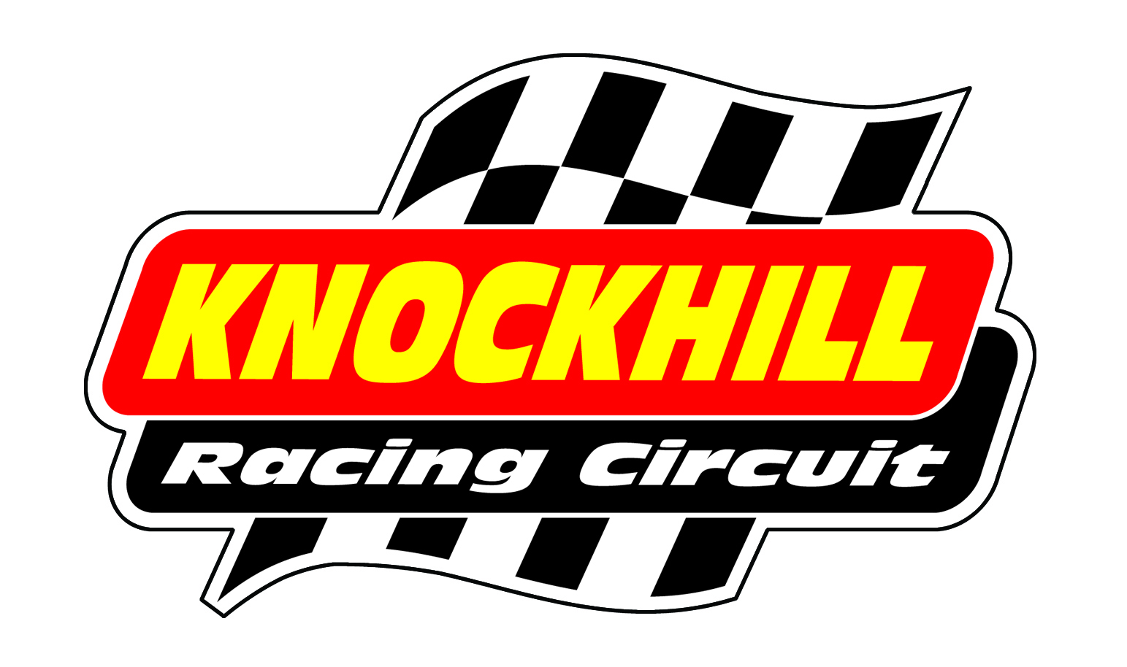
BIKE TESTING
Friday 1st August
2pm-6pm

14.00-14.15 | F125s/F400/Minitwin/Pre-Inj 600/Classic
14.20-14.35 | Superstock 600
14.40-14.55 | Superbikes/Clubman
15.00-15.15 | F125s/F400/Minitwin/Pre-Inj 600/Classic
15.20-15.35 | Superstock 600
15.40-15.55 | Superbikes/Clubman
16.00-16.15 | F125s/F400/Minitwin/Pre-Inj 600/Classic
16.20-16.35 | Superstock 600
16.40-16.55 | Superbikes/Clubman
17.00-17.15 | F125s/F400/Minitwin/Pre-Inj 600/Classic
17.20-17.35 | Superstock 600
17.40-17.55 | Superbikes/Clubman

£65 advance/£75 on the day

