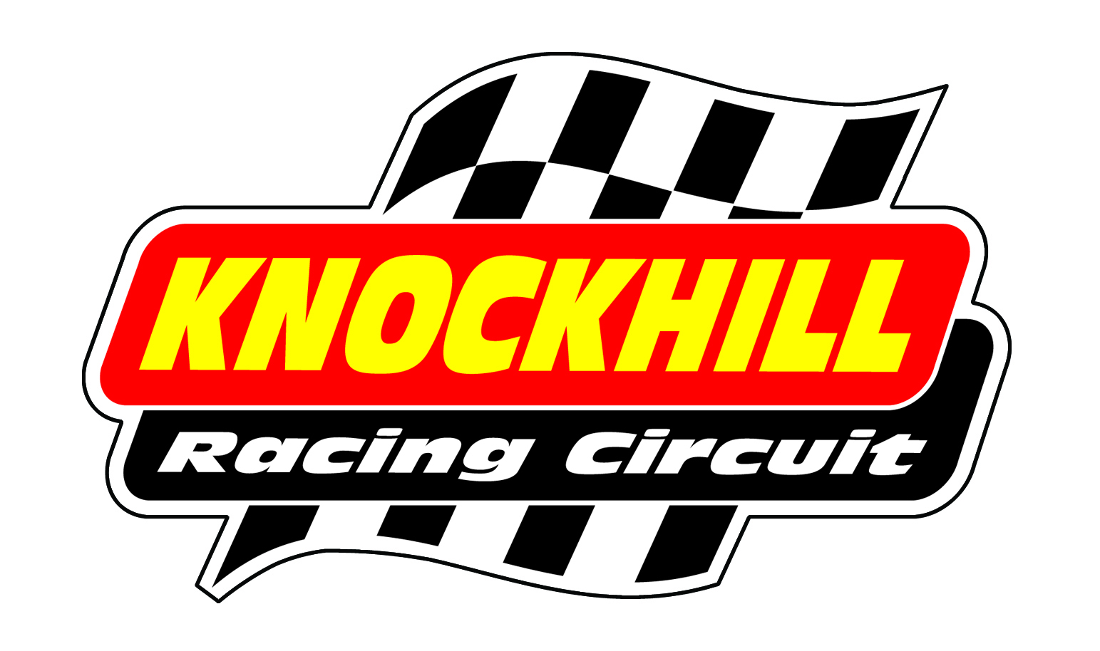
BIKE TESTING
SATURDAY 14TH MARCH
10AM – 4.30PM

10.00-10.10 | Superstock 600 / Superbike/Clubman (warm up session)
10.15-10.25 | F400 / Minitwin / Pre Injection 600 / Classic (warm up session)
10.30-10.45 | Superstock 600 / Superbike/Clubman
10.50-11.05 | F400 / Minitwin / Pre Injection 600 / Classic
11.10-11.40 | SACU New rider assessment session
11.45-12.00 | Superstock 600 / Superbike/Clubman
12.05-12.20 | F400 / Minitwin / Pre Injection 600 / Classic
12.20-13.20 | LUNCH – TRACK WALK WITH DENNIS HOBBS
13.20-13.35 | Superstock 600 / Superbike/Clubman
13.40-13.55 | F400 / Minitwin / Pre Injection 600 / Classic
14.00-14.15 | Superstock 600 / Superbike/Clubman
14.20-14.35 | F400 / Minitwin / Pre Injection 600 / Classic
14.40-14.55 | F125
15.00-15.15 | Superstock 600 / Superbike/Clubman
15.20-15.35 | F400 / Minitwin / Pre Injection 600 / Classic
15.40-15.55 | F125
16.00-16.30 | Practice start session

£75 IN ADVANCE / £85 ON THE DAY

