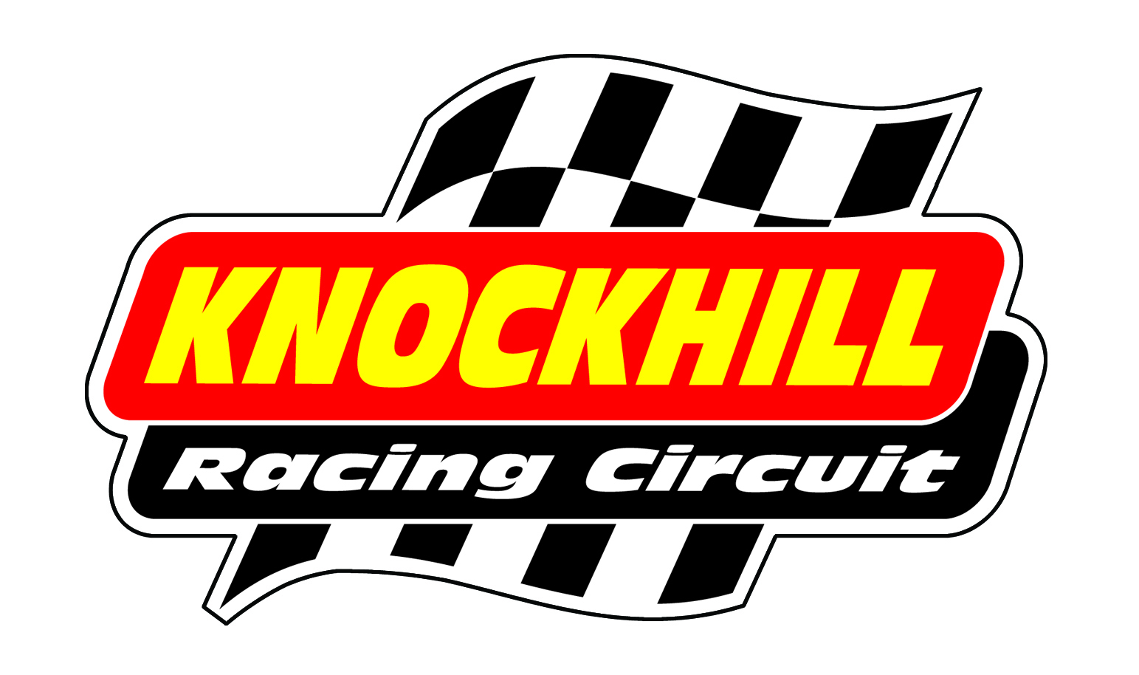
Knockhill Rewind Festival
Sunday 5TH June 2016
SHOW BIKE BOOKING FORM
Name
Address
Post Code |  | Telephone Number
Email
Make/model/year of bike (this will be printed in the programme)

Prices
Sunday Show Bike only £5
Sunday Show bike &Track Sessions – £45
Extra Spectator Ticket (covers both days) - £8

PADDOCK SET UP
There will be a ‘show bike’ area in the Paddock on Sunday 5th June. It is all outdoor space. You are welcome to bring along your own pop up tent/van if you like. Riders are welcome to come along on the Saturday with their bikes, camping is available. The main show is Sunday 5th.
TRACK TIME
There will be 2 x 15 minute sessions of track time on the Sunday. All riders must have a full UK bike licence or race licence, full leathers, ACU approved helmet, gloves and boots. The track time is run to Trackday rules, it is not a race, there’s no timing, etc.
PAYMENT
All show bike owners pay £5 for the Sunday or £45 for the show bike and track time. Extra tickets can be bought for £8 (advance prices only).
Please return this form to gemma@knockhill.co.uk
Paypal – sales@knockhill.co.uk please put your Name in the notes.
Credit/Debit Card – Please call 01383 723 337 with payment. Quote Show Bike at Rewind Festival
Closing date for show bikes is Friday 27th May.
TICKETS
Tickets will be sent to the as soon as payment is received.
All bikes must be in by 10am (gates open at 8am). Follow signs for show area.
For any questions please email gemma@knockhill.co.uk

