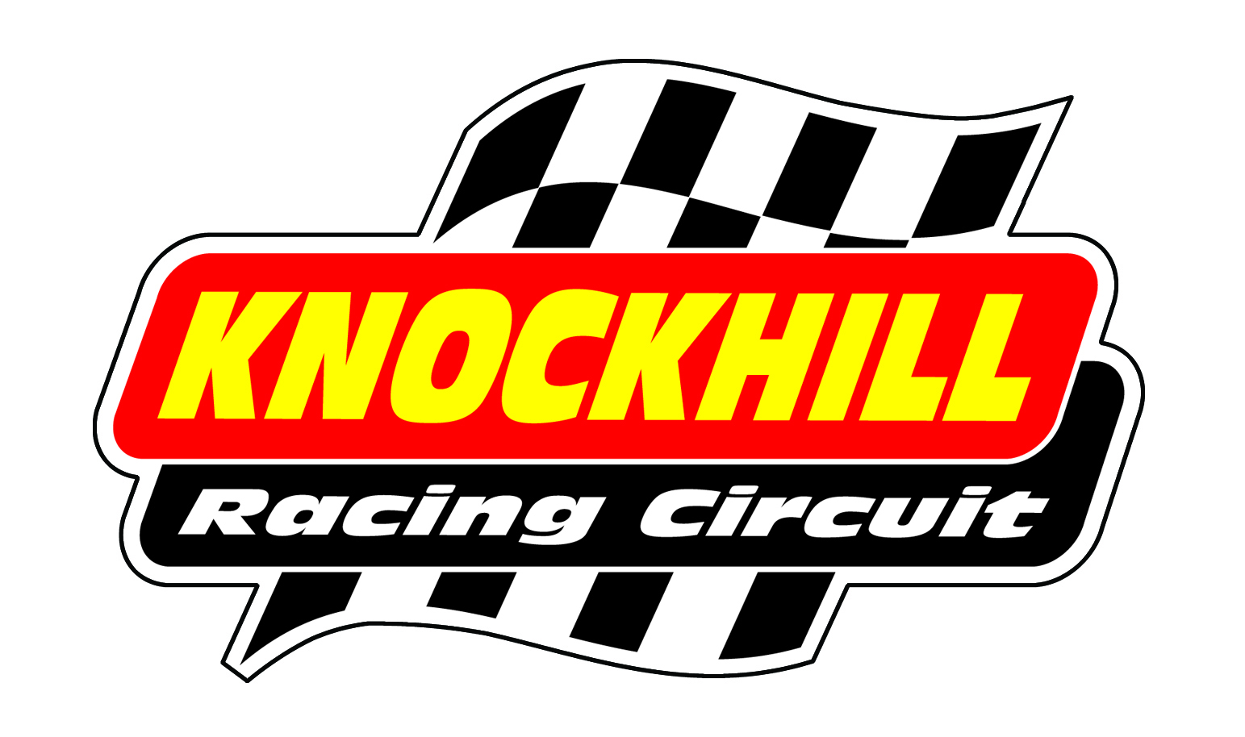
BIKE TESTING – FRIDAY 26th MAY
2pm – 6pm

Time | Class | Minutes
2.00-2.15 | Superbike/Clubman | 15
2.20-2.35 | F125 / F400 / Minitwin / Classic | 15
2.40-2.55 | Pre Injection 600 / Formula 600 | 15
3.00-3.15 | Superbike/Clubman | 15
3.20-3.35 | F125 / F400 / Minitwin / Classic | 15
3.40-3.55 | Pre Injection 600 / Formula 600 | 15
4.00-4.15 | Superbike/Clubman | 15
4.20-4.35 | F125 / F400 / Minitwin / Classic | 15
4.40-4.55 | Pre Injection 600 / Formula 600 | 15
5.00-5.15 | Superbike/Clubman | 15
5.20-5.35 | F125 / F400 / Minitwin / Classic | 15
5.40-5.55 | Pre Injection 600 / Formula 600 | 15

£79 IN ADVANCE / £89 ON THE DAY

Book online or by calling 01383 723 337

