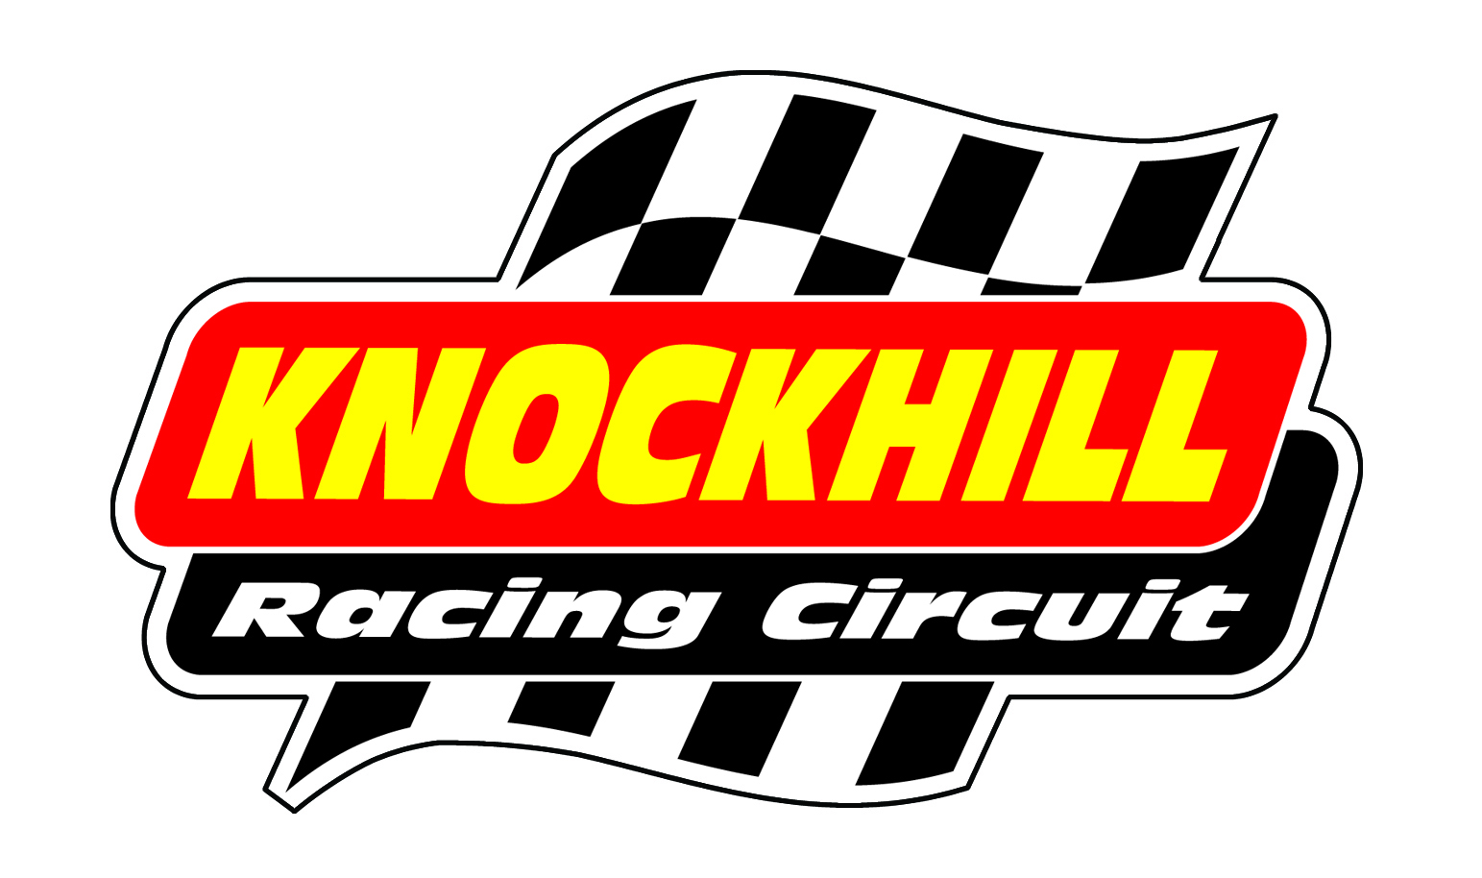
CAR TESTING TIMETABLE
SATURDAY 7TH APRIL
Time | Class | Minutes
9.00-9.15 | Mini | 15
9.20-9.35 | Classics/Saloons/BMW/Fiesta | 15
9.40-9.55 | Formula Fords | 15
10.00-10.15 | Legends | 15
10.20-10.35 | Mini | 15
10.40-10.55 | Classics/Saloons/BMW/Fiesta | 15
11.00-11.15 | Formula Fords | 15
11.20-11.35 | Legends | 15
11.40-11.55 | Mini | 15
12.00-12.15 | Classics/Saloons/BMW/Fiesta | 15
12.20-12.35 | Formula Fords | 15
12.40-12.55 | Legends | 15
13.00-14.00 | Lunch | 60
14.05-14.15 | Mini | 15
14.20-14.35 | Classics/Saloons/BMW/Fiesta | 15
14.40-14.55 | Formula Fords | 15
15.00-15.15 | Legends | 15
15.20-15.40 | Mini | 20
15.45-16.05 | Classics/Saloons/BMW/Fiesta | 20
16.10-16.30 | Formula Fords | 20
16.35-16.55 | Legends | 20

£115 in advance or £135 on the day
BOOK ONLINE OR BY CALLING 01383 723 337

