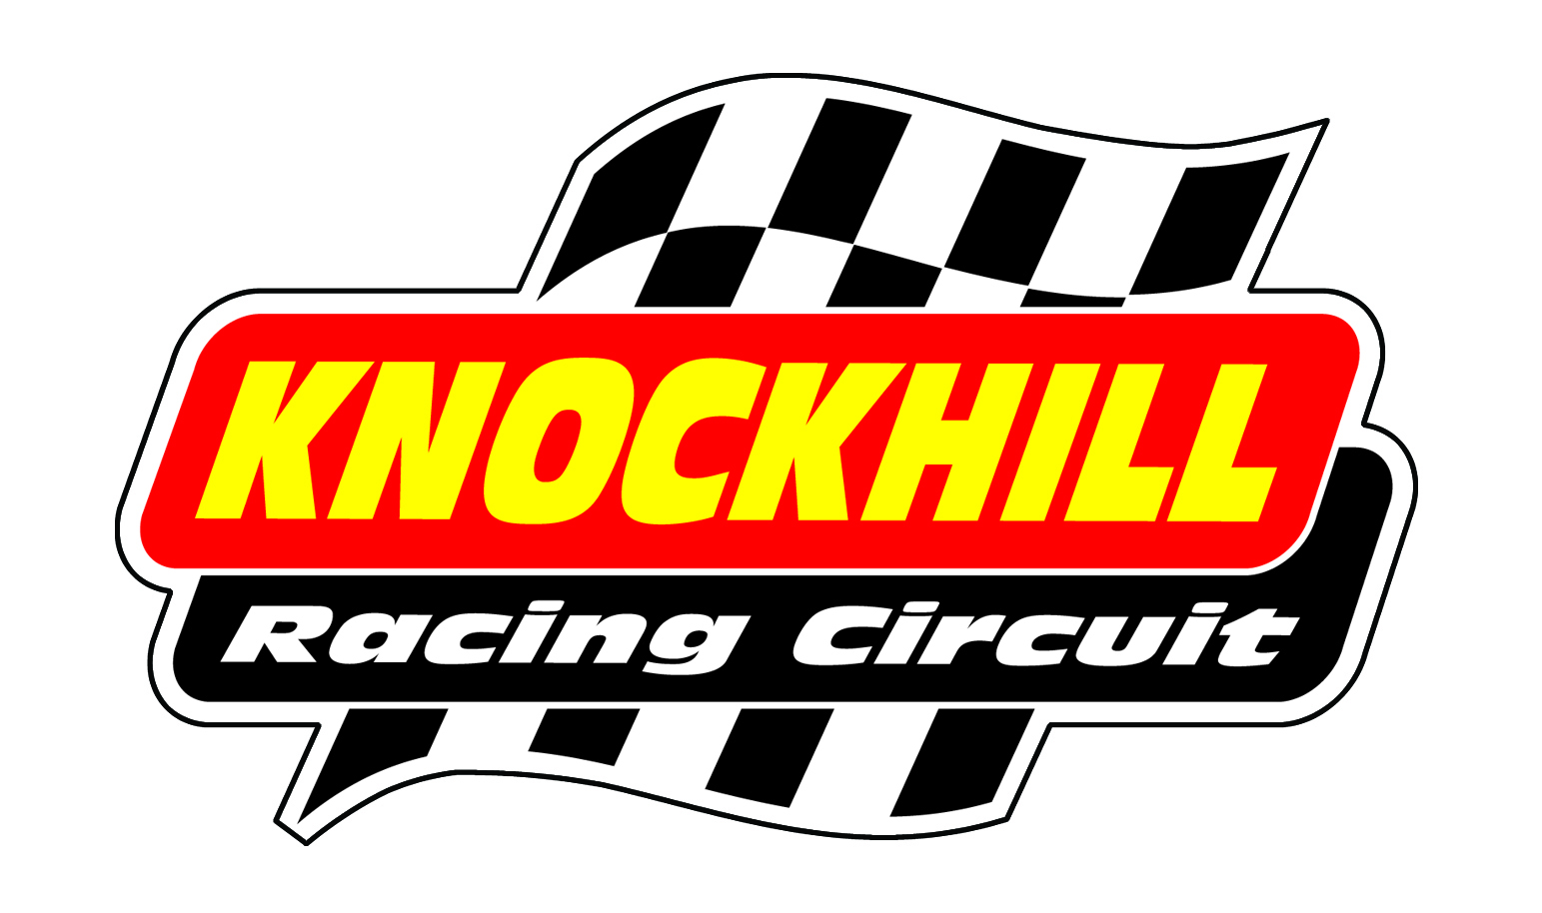
Knockhill Rewind Classic Festival
Sunday 10th June
SHOW BIKE BOOKING FORM
Name
Address
Post Code |  | Telephone Number
Email
Make/model/year of bike (this will be printed in the programme)

Prices
Sunday Show Bike - Free
Sunday Show bike &Track Sessions – £65
3 track sessions
Extra Spectator Ticket - £8

PADDOCK SET UP
There will be a ‘show bike’ area in the Paddock on Sunday 10th June. It is all outdoor space. You are welcome to bring along your own pop up tent/van if you like.
TRACK TIME
There will be 3 sessions of track time on the Sunday. All riders must have a full UK bike licence or race licence, full leathers, ACU approved helmet, gloves and boots. The track time is run to Trackday rules, it is not a race, there’s no timing, etc.
PAYMENT
All show bike owners are free of charge. For track sessions please use Paypal – sales@knockhill.co.uk please put your Name in the notes or you can call 01383 723 337 with your debit or credit card,
Please return this form to gemma@knockhill.co.uk
All bikes must be in by 10am (gates open at 8am). Follow signs for show area.

