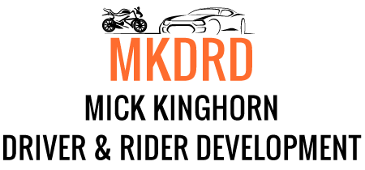

2019 Motorcycle skills development trackdays.
These days are designed for riders to develop riding skills which are transferable to the road, in a safe environment, with a team of highly skilled and experienced instructors made up of serving and retired Police riders, IAM observers/examiners, RoSPA examiners etc.
The emphasis is on skills development rather than outright lap speed.
Twenty minute sessions on track, each preceded by a short classroom input.
Three separate groups with a maximum of 20 riders on track at anytime, plus instructors. Usual ratio is four riders per instructor.

Bookings are now being taken for the following confirmed events :
Monday 29th July 2019 – Knockhill Racing Circuit, Fife KY12 9TF.
Track time from 1pm-5pm. Preceded by signing on and briefings.
4 x 20 minute sessions per rider. £129

Monday 2nd September 2019 – Croft Circuit near Darlington, DL2 2PL.
Full day.
6 x 20 minute sessions per rider. £129

For further details email enquiries@mkdrd.co.uk
Bookings now accepted via the website www.mkdrd.co.uk

